1. Open up the sql file and perform a find/replace on both the project acronym and the project ID
2. 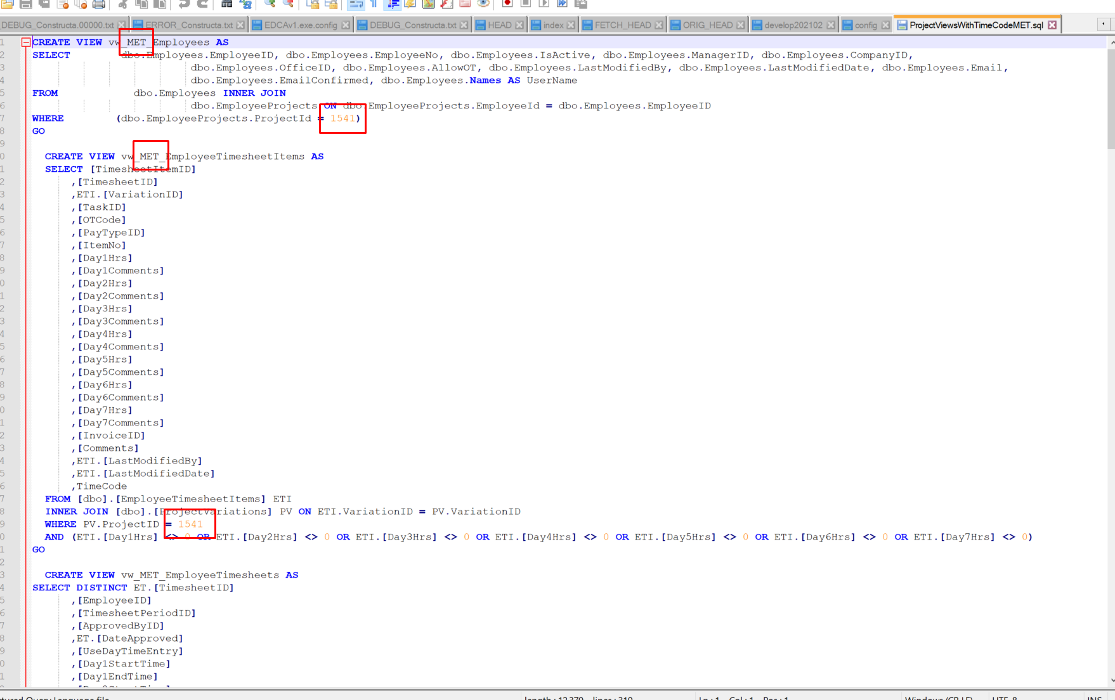
3. Run this script on the eTimeTrack database
4. Create a new security role in the eTimeTrack database
5. 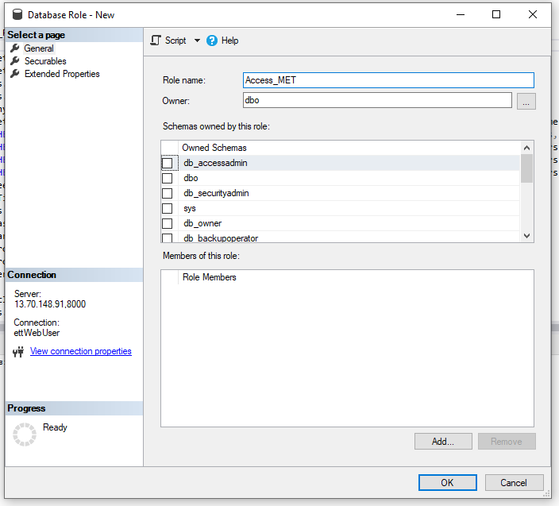
6. Assign all the created views to this role with the ‘Select’ permission’
7. 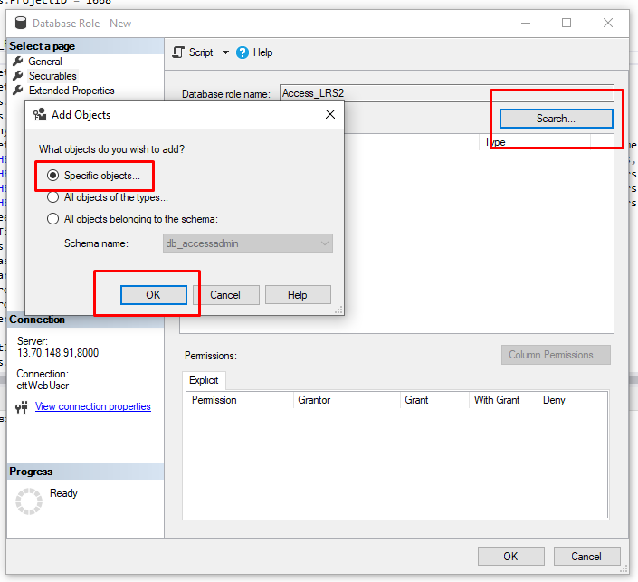
8. 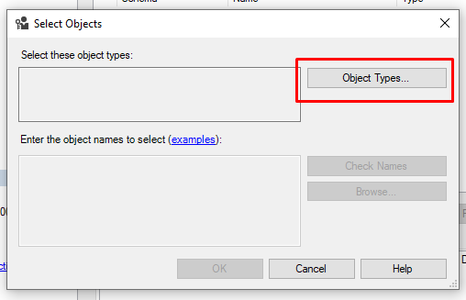
9. 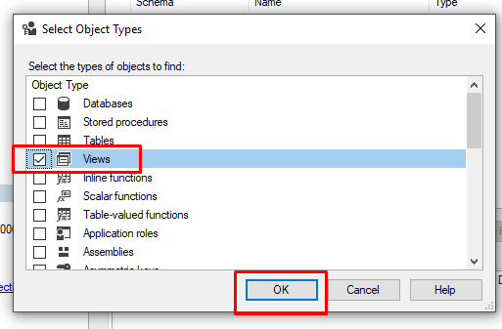
10. 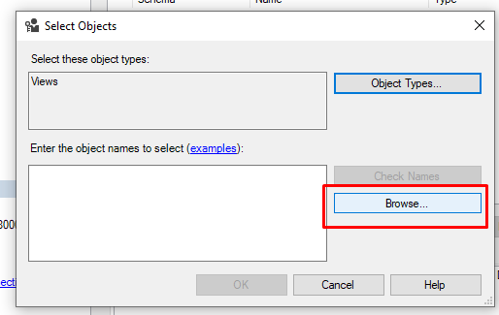
11. 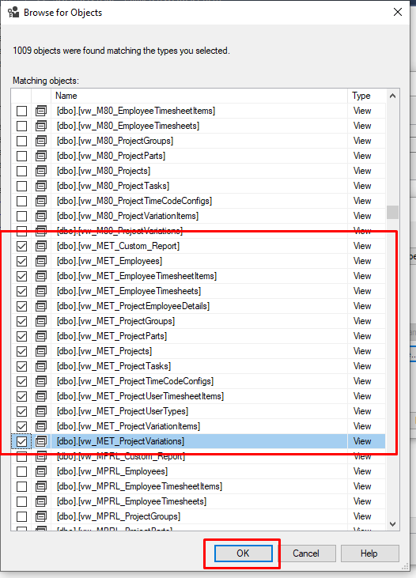
12. 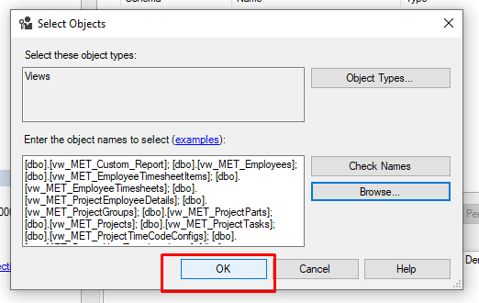
13. 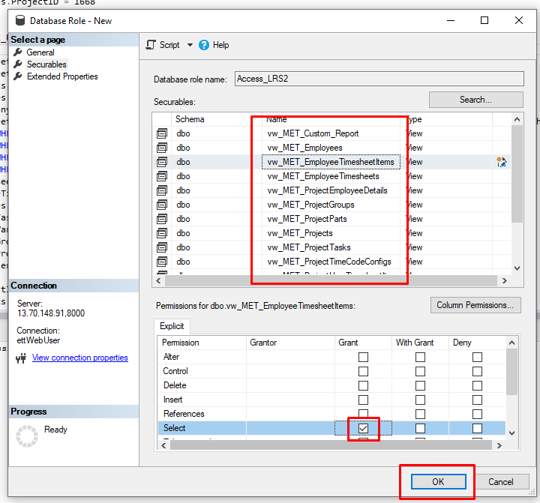
14. It will then appear in the roles list
15. 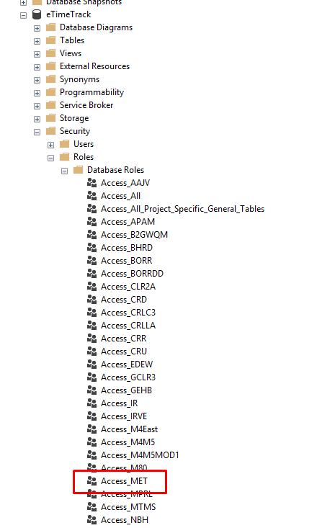
16. Assign this role to the required users as well as the ‘Access_All_Project_Specific_General_Tables’ role